John W. Carnes
December 25, 1869 – September 16, 1931

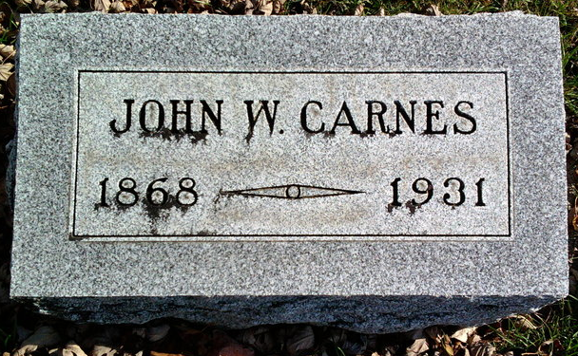
Photo by Thomas Liby

JOHN W. CARNES DIES SUDDENLY
WELL KNOWN BLUFFTON MAN DIES AT HIS HOME EARLY TODAY
John W. Carnes, 62, city employee and lifelong resident of Wells County, died suddenly at 2 o'clock this morning at his home at 734 South Marion street. He was ill only a short time. Death was attributed to heart trouble.
He was born in Chester township on Dec. 25, 1868, a son of Robert and Margaret Murray Carnes. His marriage to Alice E. Brown took place in Wells county on Nov. 7, 1891. He was a member of the Church of Christ.
Surviving besides the widow are fourteen children. Mrs. George Crawford, Mrs. Marion Dragoo, Mrs. Gerald Secrist and Mrs. Daniel Gentis, all of Muncie; Mrs. Paul Cook, Bluffton; Mrs. Ralph Johnson, Constantine, Mich.; Mrs. Bernard Roy, Fort Wayne; Rena Carnes, Oscar Carnes, Otto Carnes, Maude Carnes, Mary Carnes, Martha Carnes and Earl Carnes, all of Bluffton.
Three sisters and one brother surviving are Robert Carnes, Wells county; Mrs. William Beckler and Mrs. Fred Baker, Wells county, and Mrs. Minnie Metzgar, Oklahoma.
The funeral will be held Friday afternoon at 2 o'clock at the residence. Burial in Fairview.

Bluffton News-Banner, Wells County, Indiana
Tuesday, October 30, 1939, Page 1, Column 5

