Howard W. Carnes
November 30, 1921 – October 16, 1932

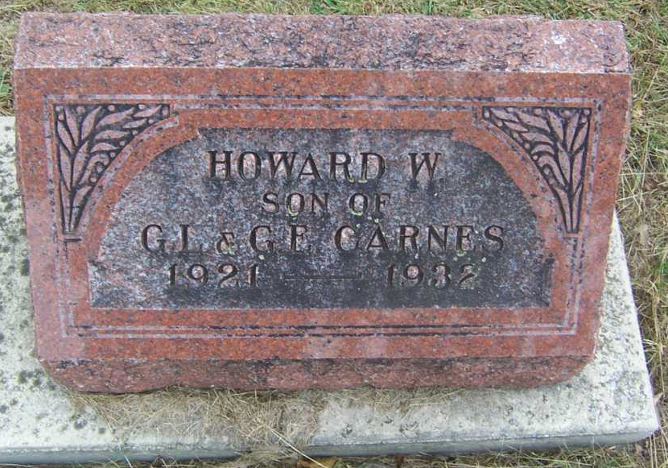
Photo by Pretty Little Grave Seekers

OSSIAN STUDENT STRUCK BY AUTO
DIES OF INJURIES
HOWARD CARNES, 11, RUNS INTO THE PATH OF CAR; WOMAN DRIVER HELD BLAMELESS
Howard Carnes, 11, son of Mr. and Mrs. Gus Carnes, near Ossian, was almost instantly killed about 4 o'clock Sunday afternoon when he ran into the path of an automobile driven by Mrs. Frank Kleinknight, Kingsland, at a point one mile south of Ossian on state road 1.
The Carnes boy and his brother, Robert, 15, had spent the afternoon at the Roe Hunter home, one mile south of Ossian. The boys had ridden from the Hunter home to the scene of the accident with William Johnloz. They got out of Johnloz's car to walk down a side road to their home about a mile southwest of Ossian.
After getting out of Johnloz's car they waited for some cars to pass but Howard evidently did not notice the Kleinknight car for he started to run across the road directly in its path. His brother saw the car and made an attempt to grab him but he missed. Howard's neck and one leg were broken. He was also badly cut and bruised.
The body of the boy was taken to Ossian by Mr. and Mrs. John Stuart. Mrs. Kleinknight suffered greatly from nervous shock as a result of the accident.
The fatal accident was witnessed by three Ossian girls Martha Hunter, Twila Vananda and Marjorie Kreigh who were enjoying a hike.
Coroner William Thoma, who investigated the accident, reported that his finding would be that death was due entirely to injuries received in an accidental manner.
The accident victim was a student in the fifth grade at the Ossian school. Besides the parents and the brother, Robert, he is survived by four sisters, Wilma, Wanda, Rose, Phyllis and Adeleen.
Surviving also are three grandparents, Mr. and Mrs. Robert Carnes and Mrs. Rose Bennett, all of Keystone.
Funeral services will be held at 1:20 Wednesday afternoon at the Presbyterian church at Ossian in charge of Rev. Raymond Pitzer. Burial will be at Fairview cemetery.

Evening News Banner, Bluffton, Wells County, Indiana
Monday, October 17, 1932, P 1, C 2

