Alice E. (Brown) Carnes
April 15, 1875 – October 29, 1939

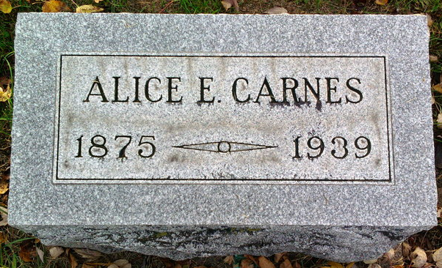
Photo by Thomas Liby

MRS. ALICE CARNES DIES AT MUNCIE
FORMER BLUFFTON RESIDENT DIES SUNDAY EVENING; FUNERAL WEDNESDAY
Mrs. Alice E. Carnes, 64, widow of John W. Carnes, and a former resident of Bluffton, died at her home at 308 North Tillotson street in Muncie following a long illness. She had been in poor health the past two years. Her death occurred at 4:15 p. m. Sunday.
Mrs. Carnes was born in Clinton county, O., on April 15, 1875, a daughter of Daniel and Emily Hayne Brown. Her marriage to John W. Carnes took place in Wells county on Nov. 7, 1891. He preceded her in death on Sept. 16, 1931. Mrs. Carnes resided in Bluffton until eight years ago when she went to Muncie. She was a member of the Church of Christ in Bluffton.
Surviving are eleven daughters, Mrs. George Crawford, of Poneto; Mrs. Marion Dragoo, of near Muncie; Mrs. Paul Cook, north of Bluffton; Mrs. Ralph Johnson, of Constantine, Mich.; Mrs. Bernard Roy, of Fort Wayne; Mrs. Gerald Secrist, of Muncie; Mrs. Daniel Gentis, of near Bluffton; Rena Carnes, of Muncie; Mrs. Elliot Lepper, of Fort Wayne; Mrs. Thomas Osborn, of Muncie; Martha Carnes, of Muncie; and three sons, Oscar Carnes near Ossian, Otto Carnes and Carl Carnes of Muncie. A sister and two brothers surviving are Mrs. Mack Dawson, of Montpelier; George Brown, of Liberty Center, and Robert Brown, of Virgil, Kansas. A brother, Clarence Brown and a sister, Mrs. George McHenry are deceased.
Short funeral services will be held at 10 a. m. Wednesday at the home in Muncie. The body will then be brought to the Thoma Funeral chapel in Bluffton where friends may call after 12 noon. Funeral services will be held at the funeral chapel at 2 p.m.
Wednesday in charge of Rev. Daugherty, of Muncie. Burial will be in Fairview cemetery.

Bluffton News-Banner, Wells County, Indiana
Tuesday, October 30, 1939, Page 1, Column 5

