Vanetta Henrietta (Williams) Byrd
September 22, 1907 – January 9, 1991

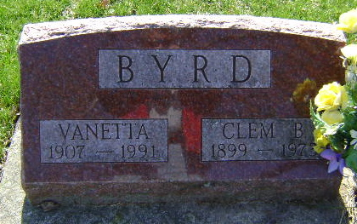
Photo by Bruce Sonner

Mrs. Vonetta Byrd, 83, Dies - Services Planned for Saturday

A former resident of 932 North Main, Mrs. Vonetta H. Byrd, 83, died at 9 p.m. Wednesday at Christian Care Retirement Community where she had been a resident the past seven months.
Born Sept. 22, 1907 in Poneto, she was a daughter of Thomas E and Fannie B. Mendenhall Williams. Her marriage to Clement B. Byrd, who died in November 1973, took place Nov. 24, 1931 in Bluffton. She was a member of the Park United Brethren Church.
Surviving are one son, Paul Byrd of Markle; one stepdaughter, Mrs. Milton (Jane) Moody of Mounty Juliet, Tenn.; one sister, Mrs. Dorothey Jean Gannon of Glendale, Calif.; 11 grandchildren and 17 great-grandchildren.
Friends may call after 1 p.m. Friday at Goodwin Memorial Chapel where services will be conducted by Rev. David Hedrick, assisted by Rev. Steve Howell, at 10:30 a.m. Saturday. Burial will follow in Fairview Cemetery. Suggested memorials to the Park United Brethren Church.

Bluffton News Banner, Wells County, Indiana
Thursday, January 10, 1991, p. 3, c. 1
**

Indiana, Death Certificates, 1899-2011
Name: Vonetta H Byrd
[Vonetta H Williams]
Gender: Female
Race: White
Age: 83
Marital status: Widow
Birth Date: 22 Sep 1907
Birth Place: Poneto, In
Death Date: 9 Jan 1991
Death Place: Bluffton, Wells, Indiana, USA
Father: Thomas E Williams
Mother: Fannie B Mendenhall
Spouse: Clement B Byrd
Informant: Paul Byrd; son; Poneto, Indiana
Burial: January 12, 1991; Fairview Cemetery; Bluffton, Indiana

