Clement Bowman “Clem” Byrd
April 21, 1899 – November 23, 1973

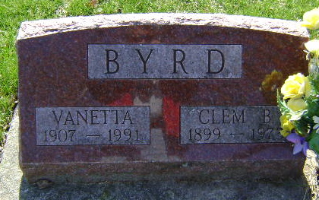
Photo by Bruce Sonner

Clem Byrd Rites At 2 P.M. Monday

A life resident of Wells County, Clem B. Byrd, 74, of 606 West Cherry St., died at 1 p.m. Friday in Clinic Hospital following a coronary attack.
A Franklin Electric retiree, he had currently been a watchman at Mix-Mill Inc.
Born in Wells County April 21, 1899, he was a son of Mr. and Mrs. A. J. (Jane Brown) Byrd. His marriage to Vanetta Williams took place in Bluffton Nov. 24, 1931.
She survives as do a daughter, Mrs. Milton (Jane) Moody of Ossian; a son, Robert Paul Byrd of Bluffton; a half-brother, Richard Cherry of Charlotte, Mich., and 11 grandchildren.
Friends may call after 7 p.m. today at the McBride Funeral Home, where Rev. Paul Fetters of Huntington College will conduct services at 2 p.m. Monday. Burial will be at Fairview Cemetery.

Bluffton News Banner, Wells County, Indiana
Saturday, November 24, 1973, p. 3, c. 2

