Roy C. Burroughs
March 29, 1878 – April 26, 1940

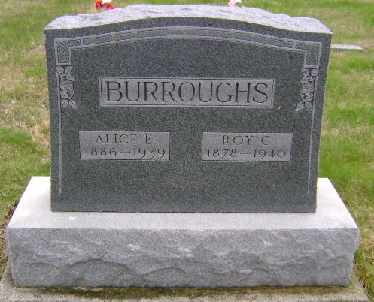
Photo by Bruce Sonner

BURROUGHS

Bluffton, April 26 - Roy Burroughs, 69, died suddenly of a heart attack here at 5 pm today, while working at a small industrial plant operated by his son-in-law, Clarence Ludwig. He was a lifelong resident of this city and was well-known as a laborer.
Surviving are two sons, Robert and John Burroughs and a daughter, Mrs. Clarence Ludwig.
The body was removed to the funeral home of R. N. Jahn. Funeral arrangements are incomplete.
Journal-Gazette, Allen County, Indiana
April 27, 1940
**

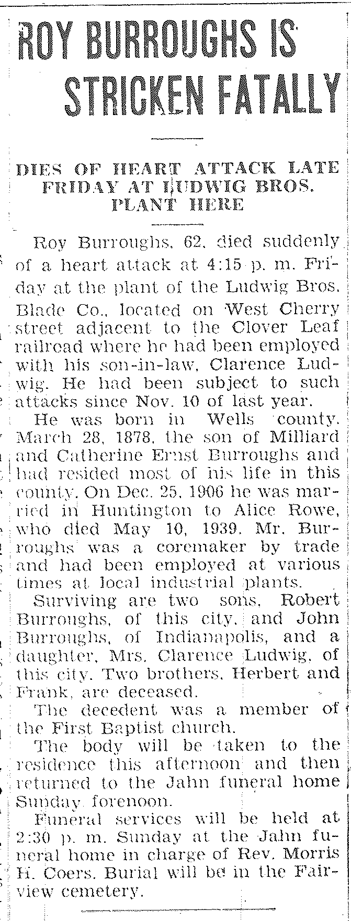
Bluffton Evening News Banner
Wells County, Indiana
Saturday, April 27, 1940
p. 1, c. 4

