Alice Emily (Rowe) Burroughs
September 24, 1886 – May 10, 1939

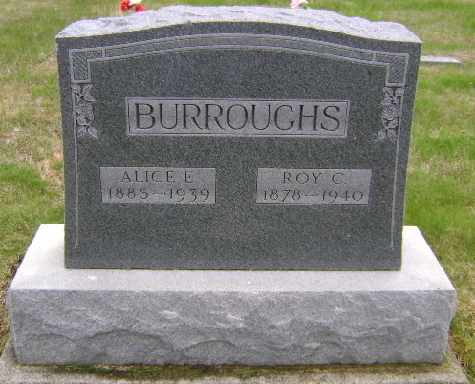
Photo by Bruce Sonner

Indiana, U.S., Death Certificates, 1899-2017
Name Alice Emmsley Burrough
[Alice Emmsley Rowe]
Gender Female
Race White
Marital Status Married
Age 52y 7m 16d
Birth Date 24 Sep 1886
Birth Place Adams County, Indiana
Death Date May 1939
Death Place Bluffton, Wells, Indiana, USA
Death Registration Date 1939
Father Charles Rowe
Mother Catherine Teving (looks like Teuigy)
Spouse Roy Burrough
Informant Mr. Roy Burrough, Bluffton, IN
Burial place not listed 5/12/1939
**

Indiana, U.S., Marriage Certificates, 1960-2012
Name Alice Rowe
Gender Female; Race White; Marriage Age 20
Birth Date 24 Sep 1886; Birth Place Liberty Center Wells
Marriage Date 25 Dec 1906; Marriage Place Huntington, Indiana
Residence Place Huntington Indiana
Spouse Charles Monroe Borroughs

