Thomas Martin Bulger
June 23, 1848 – January 23, 1924

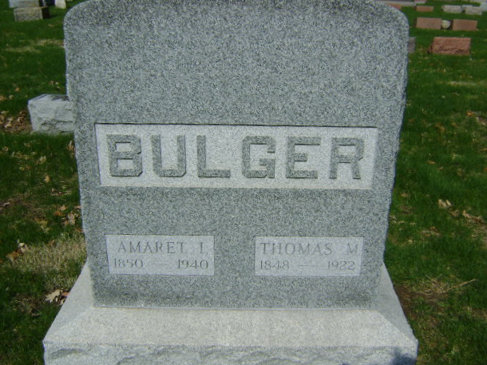
Photo by Bruce Sonner

Indiana, U.S., Death Certificates, 1899-2017
Name Thomas Martin Bulger
Gender Male
Race White
Marital Status Married
Age 75y 6m 28d
Birth Date 23 Jun 1848
Birth Place Wells Co., Indiana
Death Date 23 Jan 1924
Death Place Bluffton, Wells, Indiana, USA
Death Registration Date 1924
Father Joseph Bulger
Mother Sarah Guthrie
Spouse Armeta Davis Bulger
Informant Mrs. T. M. Bulger
Burial Fairview 1/25/1924

