Amaret Isophene (Davis) Bulger
January 23, 1850 – April 4, 1940

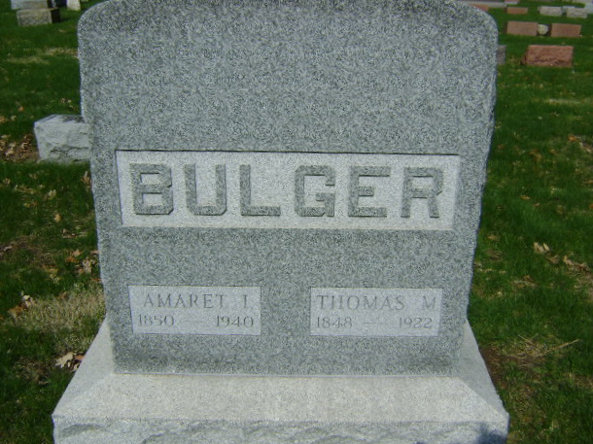
Photo by Bruce Sonner

BULGER

Bluffton, April 5 - Mrs. Amaret Bulger, 90, widow of Thomas Bulger, died at 1:10 pm today at her home here following an illness of a week from bronchial pneumonia.
Surviving are a son, Dale Bulger; six grandchildren and two great-grandchildren.

Journal-Gazette, Allen County, Indiana
April 6, 1940
**

Indiana, U.S., Death Certificates, 1899-2017
Name Amaret Isophene Bulger
[Amaret Isophene Davis]
Gender Female
Race White
Marital Status Widowed
Age 90y 2m 12d
Birth Date 23 Jan 1850
Birth Place Wells County, Indiana
Death Date 5 Apr 1940
Death Place Bluffton, Wells, Indiana, USA
Death Registration Date 1940
Father Wm P Davis
Mother Lucinda Richey
Spouse Thomas Bulger
Informant Dail Bulger, Bluffton, IN
Burial 3-7-1940 Fairview

