Ruth W. (Boyd) Buckley
July 29, 1900 – March 7, 1993

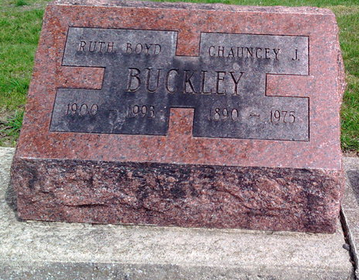
Photo by Thomas Liby

Indiana, U.S., Marriages, 1810-2001
Name Ruth W Boyd
Gender Female
Race White
Age 24
Birth Date 29 Jul 1900
Birth Place Dayton, Ohio
Marriage Date 28 Aug 1924
Marriage Place Indiana, United States
Residence Place Fort Wayne, Allen, Indiana
Father William Boyd
Mother Jennie Deam
Spouse Chauncey G Buckley
Page 323
**
U.S., Social Security Applications and Claims Index, 1936-2007
Name Ruth Wilkins Buckley [Ruth Buckley] [Ruth Wilkins Boyd]
Gender Female; Race White
Birth Date 29 Jul 1900
Birth Place Dayton, Ohio
Death Date 7 Mar 1993
Father William H Boyd
Mother Jennie Deam
SSN xxx
Notes 05 Oct 1972: Name Listed As Ruth Wilkins Buckley; 31 Mar 1993: Name Listed As Ruth Buckley

