Chauncey (Mike) Buckley
1890 – January 4, 1975

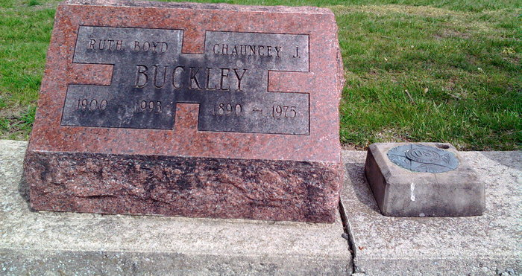
Photo by Thomas Liby

Chauncey (Mike) Buckley, 84, of Fort Wayne, a native of Adams county, died at 3:20 a.m. Saturday in Houston, Tex. Where he was visiting his son, Jack. Mr. Buckley was a carpenter for 50 years in Fort Wayne.
Surviving are his wife, Ruth, two daughters, Mrs. Ronald Brown, of Fort Wayne, and Mrs. Ruth Fairfield of Tennessee; a brother, Sam of Fort Wayne; two sisters, Mrs. Desa Henkle of Rockford, O., and Mrs. Neva Kuble of Tucson, Ariz.
Funeral services will be held at 1:30 p.m. Tuesday in Chalfant-Perry-Klaehn funeral home, Fort Wayne where friends may call from 2 to 5 and 7 to 9 p.m. today. Maumee Lodge Masonic services will be at 7:30 p.m. Monday, and Fort Wayne Chapter 432, Order of Eastern Star services will be at 8 p.m. tonight in the funeral home. Burial will be in Fairview cemetery, Bluffton.
Preferred memorial are contributions to the First Wayne Street United Methodist Church, Fort Wayne.

Decatur Daily Democrat, Adams County, Indiana
Monday, Jan. 6, 1975
**

Texas, U.S., Death Certificates, 1903-1982
Name Chauncey Jason Buckley
Gender Male
Race White
Death Age 84
Birth Date 9 Jun 1890
Birth Place Adams, Indiana
Residence Date Abt 1975
Residence Place Fort Wayne, Allen, Indiana, USA
Death Date 4 Jan 1975
Death Place Houston, Harris, Texas, USA
Father Abraham Lincoln Buckley
Mother Idola Schowalter
Informant Jack B. Busby or Burkey
Burial 1/4/1975 Fairview Cemetery
Certificate Number 03125
**
Chauncey Jason Buckley from tree Langohr Marlowe
Birth 5 Jun 1890 Adams, Indiana, USA
Marriage 28 Aug 1924 Indiana, USA
Residence 1943 Fort Wayne, Allen, Indiana, USA
Death 4 Jan 1975 Houston, Harris, Texas, USA
Father Abraham Lincoln Buckey (1860-1937)
Mother Sarah Idola Showalter (1863-1937)
Spouse Ruth W Boyd (Born 1900)
15692 People 20 Records 21 Sources

