Sarepta (Rivers) Buckles
March 8, 1867 – April 11, 1945

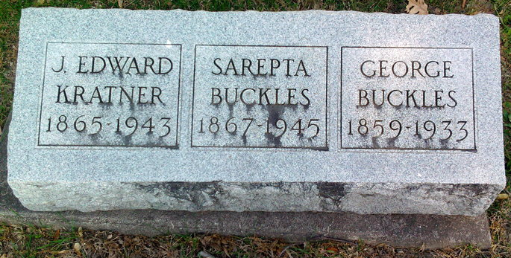
Photo by Thomas Liby

Indiana, U.S., Death Certificates, 1899-2017
Name Sarepta Buckles
[Sarepta Riners]
Gender Female
Race White
Marital Status Widowed
Age 77y 1m 3d
Birth Date 8 Mar 1868
Birth Place Warren, Indiana
Death Date 11 Apr 1945
Death Place Bluffton, Wells, Indiana, USA
Death Registration Date 1945
Father Frank B Riners (sic - Rivers)
Mother Elizabeth Grone (sic - Grove)
Spouse George Buckles
Informant Mrs. Homer Stahl, Muskegon, Mich.
Burial Fairview 4/13/1945

