Irene Buckles
1903 – July 18, 1921

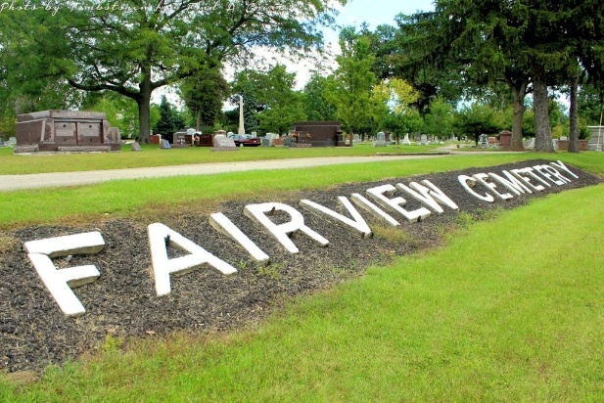
Photo by Tombstoner & Family

TWO GIRLS DROWNED IN STONE QUARRY THIS P.M.
IRENE BUCKLES AND JENNIE CONRAD; BODIES FOUND
GIRLS WERE WADING IN MEYER QUARRY AND WENT IN OVER HEAD-COULD NOT SWIM. - GIVE QUICK ALARM
Clyde Sawyer and Ken Sturgis Dive For Bodies in 10 Feet of Water.
BULLETIN
AT 4:30; AFTER WORKING AN HOUR WITH THE CONRAD GIRL THERE WAS NO SIGN OF LIFE AND LITTLE HOPE WAS GIVEN.
BULLETIN
The Conrad girl was rushed to the hospital at 4:05 after she showed some signs of life and hopes for her recovery are entertained. There was still little hope for saving the other girl.
BULLETIN
At 4 o'clock this afternoon physicians reported some hope for Jennie Conrad. No hope was given for the Buckles girl.
Irene Buckles,17, daughter of George Buckles, and Jennie Conrad, 18,daughter of Adam Conrad, were drowned in the Meyer quarry on the south side of the cemetery road at 3:15 this afternoon.
The two girls went to the quarry and were in wading on the north edge of the quarry. An elderly lady was with them. Ervin Nicholson, who was working on a dump south of the quarry gave the alarm as he heard the lady scream.
Mr. Nicholson stated that he saw the girls in wading and they seemed to be having a big time in the water. He stated they waved at him and made some remark about the water being fine. He stated he watched them for some time and then went on with his work and finally looking up as he heard one of them yell. He stated that he ran to the quarry and saw them go under. He was unable to swim and could do nothing for them.
Mr. Nichols, however, ran to the Community swimming pool on the north side of the road, where some boys were in bathing and called to them. Kent Sturgis, son of E. B. Sturgis and Clyde Sawyer, son of Wallace Sawyer, who were in the water, quickly swam to shore and rushed over to the quarry.
Mr. Nicholson showed them where the girls went down and they at once sent some smaller boys for a doctor and began diving after the bodies. They found them in about ten feet of water just at the edge of a "step off."
Dr. Caylor and Dr. Brown were the first physicians to arrive and began at once with pulmotor in efforts to revive the girls. At 3:45 this afternoon the physicians were still working in effort to bring life back.
July 19, 1921
**
STRENUOUS EFFORTS TO REVIVE TWO GIRLS FAIL-WORK 3 HOURS
IRENE BUCKLES PRONOUNCED DEAD AT 6:05 AND CONRAD GIRL DEAD AT 5:15 - TAKEN TO MORGUES
Conrad Funeral Wednesday Forenoon, Buckles in Afternoon.
Hours spent in fervent efforts on the part of four physicians failed in the resuscitation of Irene Buckles, 16, daughter of Mr. and Mrs. George Buckles, and Jennie Conrad, 15, daughter of Mr. and Mrs. Adam Conrad, of East Horton street, who were drowned Monday afternoon in the Myers quarry on the Kemp road, east of the city.
Drs. Brown, Brickley, Morris and Blackman, who gave first aid treatment to Irene Buckles on the banks of the quarry, worked until 6:05 o'clock three hours after she was taken from the water and then pronounced her dead.
Dr. C. E. Caylor, who rushed Jennie Conrad to the county hospital, pronounced her dead at 5:15 o'clock. He had held out more hope for her than the other girl when he and Dr. Brown were first taken to the scene.
According to the story told by Mrs. Conrad, mother of Jennie Conrad who witnessed the drowning, she and the girls went to the river about 2:30 o'clock and she started fishing on the southwest bank while the girls went in wading. They had provided themselves with old dresses as bathing suits, and it was their plan to wade in the shallow water along the edge as neither knew how to swim.
Mrs. Conrad said that the girls had hold of hands and that Jennie was nearest shore. Suddenly Irene stepped sideways off a ledge and lost her balance, pulling Jennie into deep water after her. They both floundered in the water and sank, both calling for help as they came to the top. They sank from sight the third time and never came up alive again.
Shocked to a point of near helplessness, Mrs. Conrad screamed to Ervin Nicholson, who was working on a dump nearby, and he went to the community swimming pool north across the roadway, where he announced the drowning to a small crowd of swimmers.
Clyde Sawyer brought the body of Jennie Conrad up as he dived in the spot pointed out by the mother of the girl. Kendrick Sturgis, another swimmer, went down in the same spot and found the body of Irene Buckles about six feet to the north of the place where the Conrad girl was found. Both bodies were a foot off the bottom.
In the meantime other bathers rushed to the city for doctors who responded quickly. The bodies had been in the water ten minutes and it was about ten minutes before the doctors arrived. The doctors set to work with determined effort and they are deserving of much credit for the hard efforts they put forth to bring back life to the patients.
At 4:30 the Conrad girl was taken to the county hospital where three quarters of an hour was spent with the pulmotor in effort to revive her. After she was pronounced dead she was taken to the McBride undertaking parlors, where she was viewed by friends today.
After the Buckles girl was pronounced dead at 6:05, she was taken to the Thoma undertaking parlors where the body is being viewed by friends today.
Jennie Conrad, aged fifteen years, two months and thirteen days, was born in this city, a daughter of Adam and Ellen Kahn Conrad. She received her education in the city schools.
She is survived by the parents, a brother George Conrad, a recent candidate for mayor at the democratic primary, and four sisters, Lydia Forkner, of Bowen, Ky.; Helen Conrad, Mrs. Clara Ernst, at home, and Mrs. Forest Dishong.
Conrad Funeral Tomorrow.
The body of Jennie Conrad will be taken home at 9 o'clock
tomorrow and at 1 o'clock in the afternoon the cortege will leave for St. Paul's church in Rockcreek township, where the funeral service will be held. Burial will be in St. Paul cemetery.
Buckles Girl is Eighteen.
Irene Buckles, aged eighteen years, was the daughter of Mr. and Mrs. George Buckles. She was a lifelong resident of this city. She is survived by the parents and two brothers, Harold and Neil. The family lives at 204 East Horton street.
Mr. Buckles has been employed at Lansing, Mich., and at 3:30
o'clock this afternoon no reply had been received to the message sent him announcing his daughter's death.
The funeral service of Irene Buckles will be held at 4:30
o'clock Wednesday afternoon at the Ellen Costello home on East Horton street in charge of Rev. Dayton. Burial will be at Fairview.

Evening Banner, Wells County, Indiana
July 18, 1921, p. 1
**

Indiana, U.S., Death Certificates, 1899-2017
Name Irine Buckles
Gender Female
Race White
Marital Status Single
Age 18y 9m 7d
Birth Date 11 Oct 1902
Birth Place Wells County, Indiana
Death Date 18 Jul 1921
Death Place Bluffton, Wells, Indiana, USA
Death Registration Date 1921
Father George Buckles, informant
Mother Katheryn Costello
Burial Fairview 7/20/1921

