George Buckles
1859 – February 26, 1933

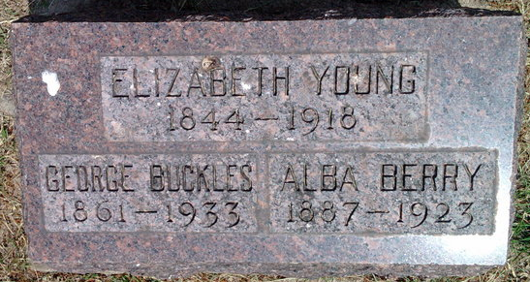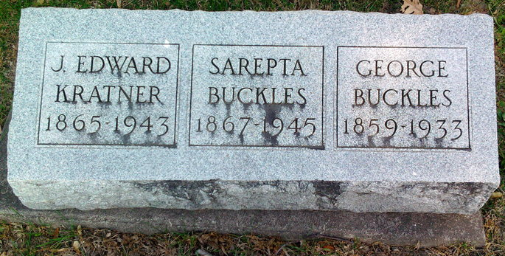
Photos by Thomas Liby
Note: different birth years on the stones

Indiana, U.S., Marriage Certificates, 1960-2012
Name Geo C Buckles
Gender Male
Marriage Date 26 Dec 1901
Marriage Place Wells, Indiana, USA
Mother Matilda Fox
Spouse Catherine L Costello
Officiator R R Shoemaker

