Mary Jo (Browder) Brink
September 28, 1927 – August 20, 2018

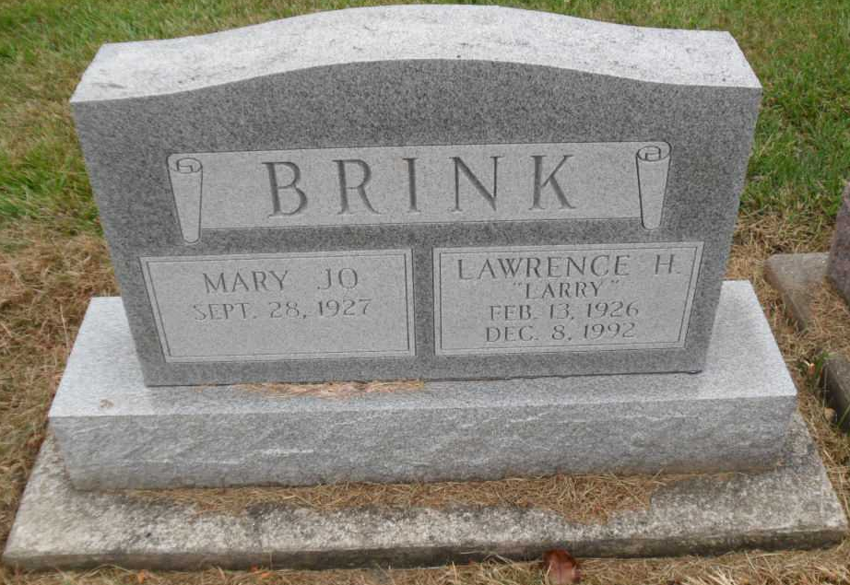
Photo by Pretty Little Grave Seekers

Mary Jo Brink, 90, of Bluffton, passed away on Monday afternoon, August 20, 2018, at River Terrace Estates in Bluffton.
She was born on September 28, 1927 in Indianapolis, Indiana to Ramon H. & May Doreen (McEnaney) Browder. She graduated from Shortridge High School and completed college classes for over 2 years at both Purdue & Butler University. Mary Jo was a longtime member of the First Presbyterian Church in Bluffton along with Alpha Chi Omega and Tri Kappa Sorority.
On November 19, 1955 in Indianapolis, Mary Jo and Lawrence H. Brink were married. They shared 37 years together before he preceded her in death on December 8, 1992.
A homemaker, Mary Jo work at the Bluffton State Farm Insurance Office for 15 years, retiring in 1989.
Survivors include two sons; William H. Brink and Daniel J. (Jennifer) Brink, both of Bluffton along with 7 grandchildren and 4 great-grandchildren.
Calling Hours will be held from 12 Noon to 6 P.M. on Thursday at the Thoma/Rich, Lemler Funeral Home in Bluffton. A service to celebrate her life will take place at 6 P.M. on Thursday (August 23, 2018) and will include a Tri Kappa Memorial Service. Burial will take place at a later date at Fairview Cemetery in Bluffton. Memorials may be made to the First Presbyterian Church.
Thoma/Rich, Lemler Funeral Home, Wells County, Indiana
August 21, 2018

