Lawrence Henry Brink Jr.
February 13, 1926 – December 8, 1993

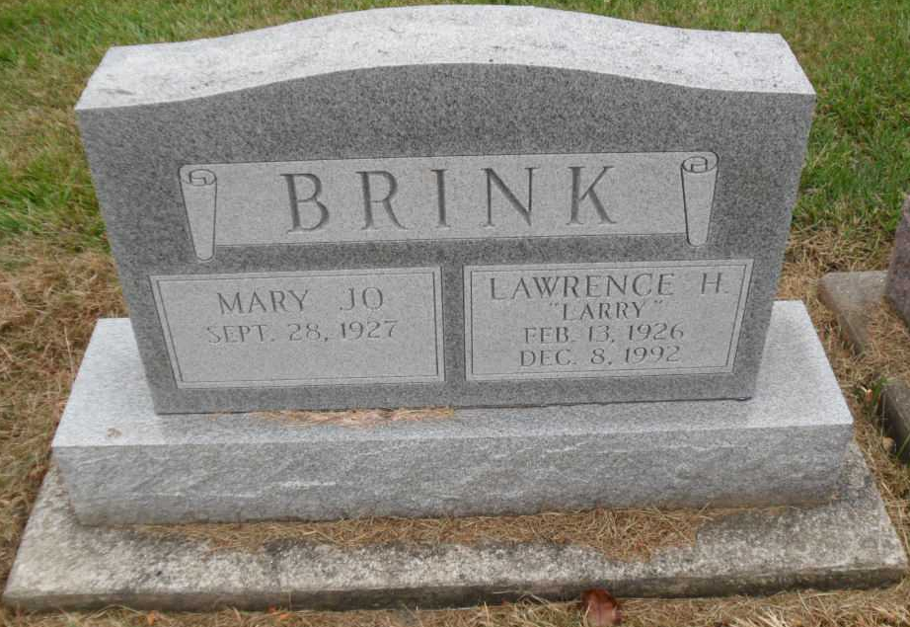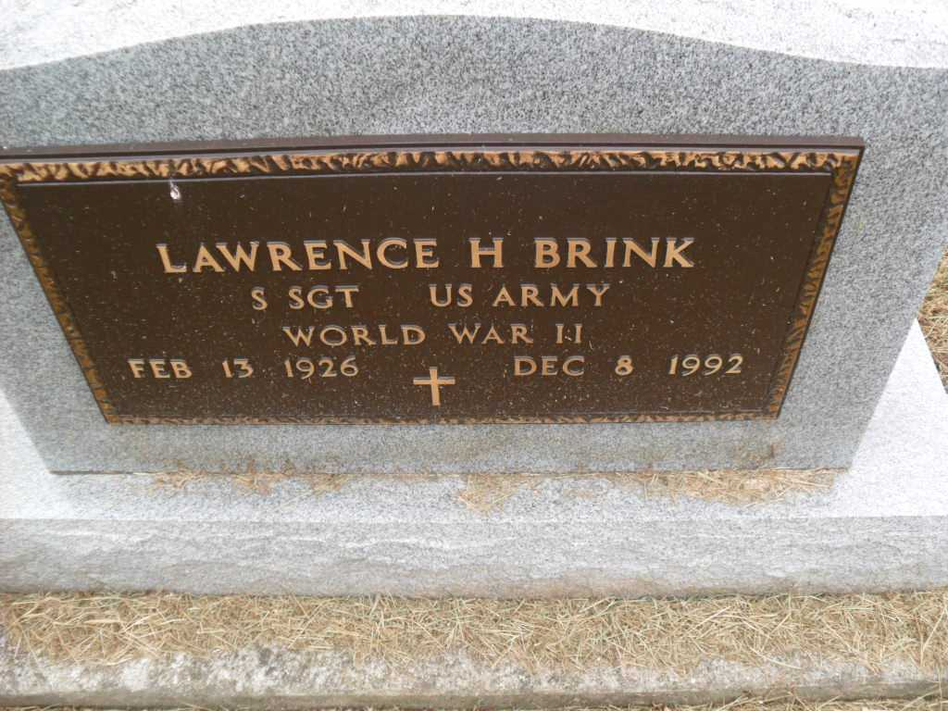
Photos by Pretty Little Grave Seekers

Indiana, U.S., Death Certificates, 1899-2017
Name Lawrence H Brink Jr
Gender Male
Race White
Marital Status Married
Age 66
Military WW II veteran
Birth Date 13 Feb 1926
Birth Place Indianapolis, Indiana
Death Date 8 Dec 1992
Death Place Bluffton, Wells, Indiana, USA
Death Registration Date 1992
Father Lawrence H Brink Sr.
Mother Ellen B Snoddy
Spouse Mary Jo (Browder) Brink, informant
Disposition Ft. Wayne Crematory 12/11/1992

