Thomas Jefferson Brickley
September 21, 1866 – August 20, 1940

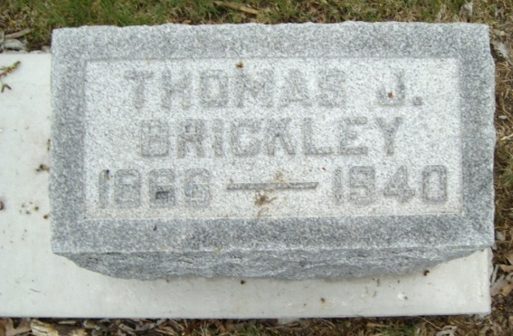
Photo by Bruce Sonner

Indiana, U.S., Death Certificates, 1899-2017
Name Thomas Jefferson Brickley
Gender Male
Race White
Marital Status Married
Age 73y 10m 29d
Birth Date 21 Sep 1866
Birth Place Rockcreek Twp Wells Colorado
Death Date 20 Aug 1940
Death Place Bluffton, Wells, Indiana, USA
Cause of death suicide; shotgun wound thru heart & chest
Death Registration Date 1940
Father Lewis A Brickley
Mother Catherine Lesh
Spouse Minnie (Moser) Brickley
Informant Dr. H D Brickley, Bluffton, IN
Burial Fairview Cemetery, 8/22/1940

