Raymond Brickley, Pvt.
May 3, 1897 – February 12, 1918

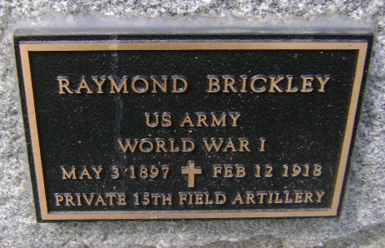
Photo by Bruce Sonner
Fort Wayne News and Sentinel, Allen County, Indiana
June 6, 1921
[Cite your source here.]
