William Theodore Bricker
August 17, 1908 – March 26, 1994

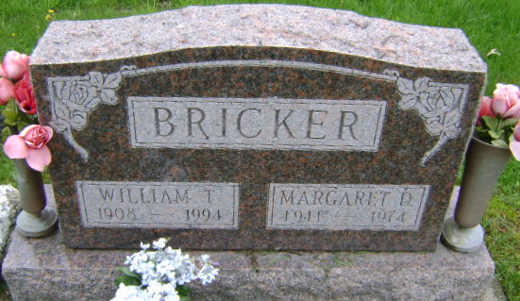
Photo by Bruce Sonner

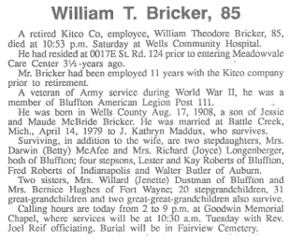
Bluffton News Banner, Wells County, Indiana
Monday, March 28, 1994, p. 3, c. 1

