Dorothy Margaret (Eversole) Bricker
April 27, 1911 – April 23, 1974

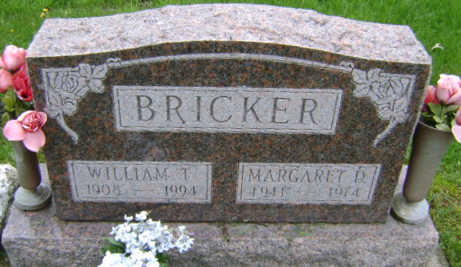
Photo by Bruce Sonner

Mrs. Dorothy Margaret Bricker, 62, wife of William T. Bricker,
911 Home Street died today at Wells Community Hospital.
Born April 27, 1911 in Huntington County, she was a daughter of Charles E. and Nellie A. Wall Eversole. Her marriage to Mr. Bricker took place in 1963 in Bluffton. She was a resident of Wells County most of her life.
Also surviving are the mother, of Poneto; a foster daughter, Mrs. Brenda Garner of Petroleum; two brothers, Woodrow Eversole of Markle and Charles Eversole of Fort Wayne; a sister, Mrs. William (Helen) Paxson of Bluffton and two foster grandchildren.
Services will be Thursday at the Thoma-Rich Funeral Home with Rev. James Robins officiating; burial in Fairview Cemetery.
Wells County, Indiana Obituaries
April 23, 1974
**

Indiana, Death Certificates, 1899-2011

Name: Dorothy Margaret Bricker
[Dorothy Margaret Eversole]
Gender: Female
Race: White
Age: 62
Marital status: Married
Birth Date: 27 Apr 1911
Birth Place: Indiana
Death Date: 23 Apr 1974
Death Place: Bluffton, Wells, Indiana, USA
Father: Charles E Eversole
Mother: Nellie A Wall
Spouse: William Bricker
Burial: Fairview Cem. 4-25-1974

