Frieda M. Brandyberry
July 16, 1904 – April 12, 1969

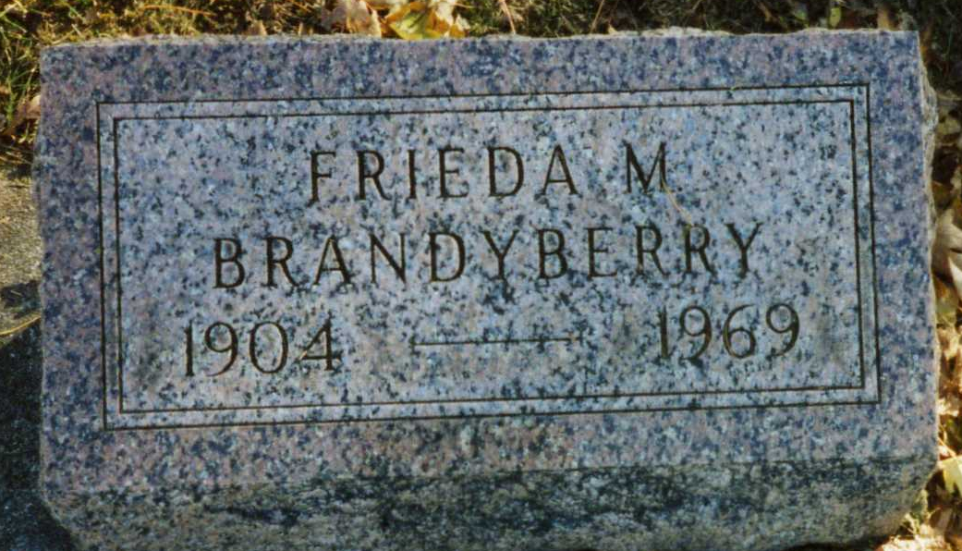
Photo by drbuck
Frieda Brandyberry
in the Indiana, U.S., Death Certificates, 1899-2017
Name: Frieda Brandyberry
Gender: Female
Race: White
Age: 64
Marital status: Divorced
Birth Date: 16 Jul 1904
Birth Place: Indiana
Death Date: 12 Apr 1969
Death Place: Bluffton, Wells, Indiana, USA
Death Registration Date: 1969
Father: Emerson Brandyberry
Mother: Bessie Kershner
Informant: Bessie Mowery; mother; Bluffton, Indiana
Burial: April 15, 1969; Fairview Cemetery; Bluffton, Indiana

**
Russell Aubry Bumgardner
in the Indiana, U.S., Marriage Certificates, 1960-2012
Name: Russell Aubry Bumgardner
Gender: Male
Age: 58
Birth Date: abt 1904
Birth Place: Sandimon,
Marriage Date: 14 Dec 1962
Marriage Place: New Haven, Allen, Indiana, USA
Marriage Registration Date: 1962
Reference Number 1: Bx1452
Reference Number 2: Tr8501
Spouse: Frieda Marie Brandyberry; b. abt 1904 Wells County, Indiana
Box Number: NA
Volume Number: NA
Certificate Number: 62 - 000078

