Effie Gladys (Terhune) Bradburn
August 28, 1898 – January 6, 1969

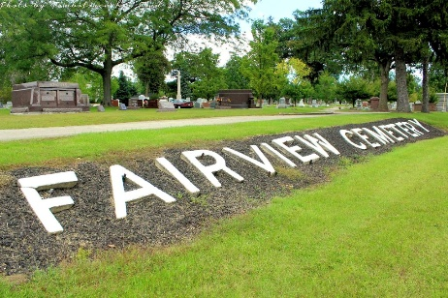
Photo by Tombstoner & Family

Indiana, U.S., Death Certificates, 1899-2017
Name Gladys Bradburn
[Gladys Terhune]
Gender Female
Race White
Marital Status Married
Age 70
Birth Date 28 Aug 1898
Birth Place Indiana
Death Date 6 Jan 1969
Death Place Bluffton, Wells, Indiana, USA
Death Registration Date 1969
Father Albert Terhune
Mother Susan Jones
Spouse Clifford Bradburn, informant
Burial 1-8-1968 Fairvier
**
Effie Gladys Terhune from tree Schultze-Reindel Family Tree
Birth 28 Aug 1898 Wells, Indiana, USA
Marriage 17 Oct 1914 Hillsdale, Hillsdale, Michigan, USA
Residence 1965 Indiana, USA
Death 6 Jan 1969 Bluffton, Wells, Indiana, USA
Father Albert Ethelbert Terhune (1851-1934)
Mother Susan A Jones (1858-1919)
Spouse Clifford Raymond Bradburn (1894-1973)
133899 People 16 Records 20 Sources

