Clifford Raymond Bradburn
June 2, 1894 – April 11, 1973

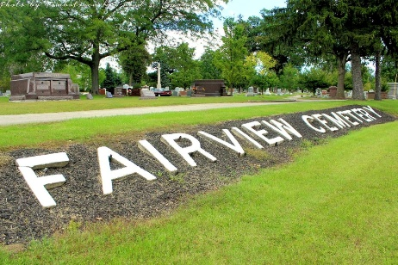
Photo by Tombstoner & Family

Clifford R. Bradburn, 78, of 807 Oak Street died today in Wells Community Hospital. Born June 2, 1894 in Tipton County, he was a son of William and Phoebe Stephens Bradburn. He was married to Gladys Terhune, who died January 6, 1969. A member of First Presbyterian Church, he had resided in Wells County most of his life.
Surviving are five daughters, Mrs. Paul (Maro) Bender of Bluffton; Mrs. Joe (Ruby) Fudge of Route 1, Grabill, Mrs. William (Irene) Watkins of Poneto, Route 1, Mrs. Lester (Ruth) McIntire of Route 1, Montpelier, and Mrs. James (Jane) Low of Jacksonville, Texas; three brothers, Orvan Bradburn of Coldwater, Michigan, Olis Bradburn of Franklin, North Carolina and Cecil Bradburn of Route 5, Huntington, nine grandchildren and nine great grandchildren.
Services will be held Friday at the Thoma Funeral Home, Bluffton; Rev. Philip Hazelton officiating; entombed in the Fairview Mausoleum.
Clifford Raymond Bradburn married Effie Gladys Terhune 17 Oct 1914 Hillsdale, Hillsdale County, Michigan.

Wells County, Indiana Obituaries
April 11, 1973
**

Indiana, Death Certificates, 1899-2011

Name: Clifford R Bradburn
Gender: Male; Race: White; Age: 78
Marital status: Widowed
Birth Date: 2 Jun 1894
Birth Place: Indiana
Death Date: 11 Apr 1973
Death Place: Bluffton, Wells, Indiana, USA
Father: William Bradburn
Mother: Phoebe Stephens
Informant: Mrs Maro Bender, daughter
Burial: Fairview Mausoleum 4-13-1973

