James W. Bowman
March 27, 1924 – January 16, 2017

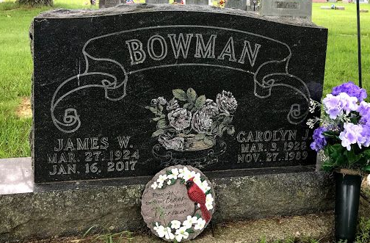
Photo by SMMR

James W. Bowman, 92, of Bluffton passed away at 12:46 p.m. on Monday, January 16, 2017, at Signature Health Care in Bluffton.
Mr. Bowman was born on March 27, 1924 in Decatur, Indiana to Charles & Velma (Lenhart) Bowman. He graduated from Rockcreek Township High School and served his country during World War II in the Army Air Corps, in the 86th Fighter Bomber Group. He retired from Franklin Electric in 1982, after working for 36 years as a production foreman. He was a member of the American Legion Post #111 of Bluffton, served as a Boy Scout Committeeman and was a member of the First United Methodist Church in Bluffton. He loved to spend time at his purple lake cottage fishing and working in his rose garden
On April 13, 1946, Jim and Carolyn J. (Murray) Bowman were married and she preceded him in death on November 27, 1989.
Survivors include two sons; William C. Bowman and Jeffrey L. Bowman, both of Bluffton along with 6 grandchildren and 8 great-grandchildren.
He is preceded in death by his wife Carolyn, a son Keith M. Bowman along with brothers: Kenneth & Gail Bowman and a sister Madeline Mosure.
A service to celebrate Jim’s life will be held at 10:30 a.m. on Saturday, (January 21, 2017) at the Thoma/Rich, Lemler Funeral Home in Bluffton. Pastor Steve Bard will officiate. Burial will follow at Fairview Cemetery in Bluffton where military honors will be given by the American Legion Post #111 of Bluffton and the United States Army Honors Guard.
Calling hours will be held from 2 to 8 p.m. on Friday at the Thoma/Rich, Lemler Funeral Home and for one hour prior to the service on Saturday. Memorials may be made to Heartland Hospice or to the First United Methodist Church.
Funeral arrangements have been entrusted to the care of the Thoma/Rich, Lemler Funeral Home in Bluffton.

Thoma/Rich Funeral Home, Wells County, Indiana
January 17, 2017

