Carolyn J. (Murray) Bowman
March 3, 1928 – November 27, 1989

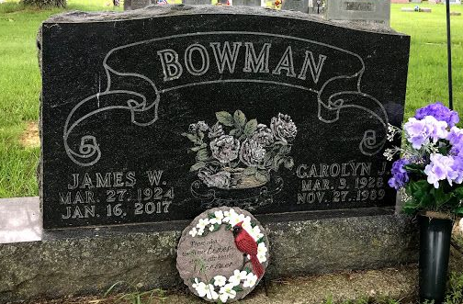
Photo by SMMR

Indiana, U.S., Death Certificates, 1899-2017
Name Carolyn J Bowman
[Carolyn J Murray]
Gender Female
Race White
Marital Status Married
Age 61
Birth Date 3 Mar 1928
Birth Place Bluffton, Indiana
Death Date 27 Nov 1989
Death Place Fort Wayne, Allen, Indiana, USA
Death Registration Date 1989
Father Harold E Murray
Mother Vera L White
Spouse James W Bowman, informant
Burial 11/30/1989 Fairview, Bluffton, IN

