Jo Ella (Erlet) Bowen-Evans
May 10, 1934 – January 24, 2011

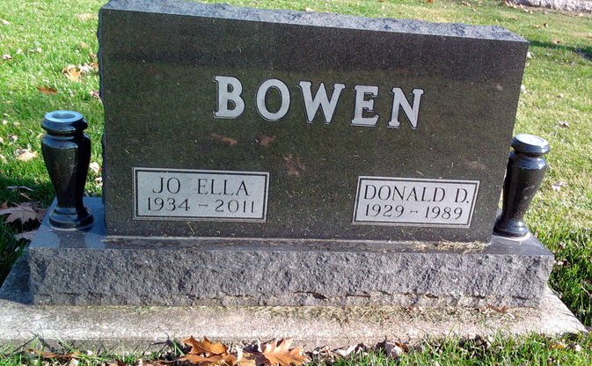
Photo by Thomas Liby
Jo Ella Evans, 76, of Bluffton passed away at 3:30 a.m. Monday, January 24, 2011. Jo Ella worked in the Clerical Department at Wells Community Hospital for eleven years retiring in 2000. She was a 1952 graduate of Portland High School and lived most of her life in Adams and Wells Counties except for four years when she resided in Tampa, Florida. Jo Ella was a member of the First United Methodist Church in Bluffton.
Jo Ella was born May 10, 1934 in Dayton, Ohio, to James Erlet and Golda Journay Erlet. On September 26, 1953 in Liberty Center, Indiana, she married Donald D. Bowen; he preceded her in death on May 7, 1989. On April 29, 1994 in Bluffton, Indiana, Jo Ella married Rev. Jual H. Evans and he survives and resides in Bluffton.
Survivors include a son, Michael (Sharice) Bowen of Uniondale; a daughter, Tina (Phil) Baumgartner of Bluffton; two step-daughters, Judith (Phil) Blackwell of Umatilla, Florida and Linda (John) Maher of Marion, Indiana and seven grandchildren.
She was also preceded in death by three sisters; Donna Murley, Betty Stults and Mary Ann Stultz.
Calling hours will be 2:00 to 8:00 p.m. Wednesday, January 26, 2011 at Thoma/Rich, Chaney & Lemler Funeral Home and one hour prior to services on Thursday, January 27, 2011 at the church. Funeral services will be held at the First United Methodist Church at 10:30 a.m. Thursday, January 27, 2011 with Pastor Cindy Osgood officiating. Burial will be in Fairview Cemetery.
Preferred memorials are to the First United Methodist Church or Family Hospice & Palliative Care.
Thoma/Rich, Chaney & Lemler Funeral Home, Wells County, Indiana

