Donald Dean Bowen
June 11, 1929 – May 15, 1989

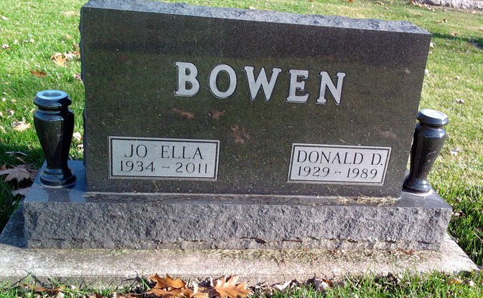
Photo by Thomas Liby
U.S., Social Security Applications and Claims Index, 1936-2007
Name Don Dean Bowen
[D D Bowen]
Gender Male
Race White
Birth Date 11 Jun 1929
Birth Place Bluffton Wel, Indiana
Death Date 15 May 1989
Father Lloyd Bowen
Mother Justine Sawyer
SSN xxx
Death Certificate Number 051854
Notes May 1947: Name Listed As Don Dean Bowen; 22 May 1998: Name Listed As D D Bowen
**
Donald Dean Bowen from tree Bowen Family Tree
Birth 11 Jun 1929 Bluffton, Wells, Indiana, USA
Residence 1940 Wells, Indiana, USA
Death 7 May 1989 Hillsborough, Florida, USA
Father Lloyd BOWEN (1899-1982)
Mother Justine Robison Robinson Sawyer (1900-1991)
Spouse Jo Ella Erlet (1934-2011)
930 People 2 Records 2 Sources

