Lewis A. Boden
September 19, 1875 – January 13, 1934

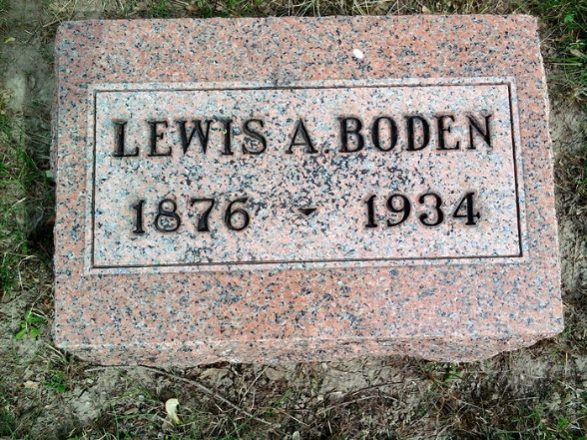
Photo by Thomas Liby

LEWIS A. BODEN TAKEN BY DEATH.
DEATH OCCURS EARLY TODAY AT WELLS COUNTY FARM.

Lewis A. Boden, 57, died at 7 o'clock this morning at the Wells County Infirmary. He had been in poor health for a number of years.
Born in Bluffton on Sept 19, 1876, he was a son of William and Elizabeth Wertz Boden. He spent his entire life in Bluffton. On Nov 7, 1903 he was married at Poneto to Bertha Bennett, from whom he was divorced.
Surviving are two daughters, Ruth E. and Mary M. Boden, both of Bluffton. Two children, Bernice and Mildred are deceased. A brother, Charles Boden, Francisville, and a half-brother, George Stover, Bluffton, also survive. Two sisters preceeded him in death.
Funeral services will be held at 2 o'clock Monday afternoon at the Thoma funeral chapel, in charge of Rev. P.B. Smith. Burial will be in the Fairview Cemetery.

Bluffton Evening News, Wells County, Indiana
14 Jan 1934

