Jessie Earl Baxter
September 30, 1897 – June 29, 1924

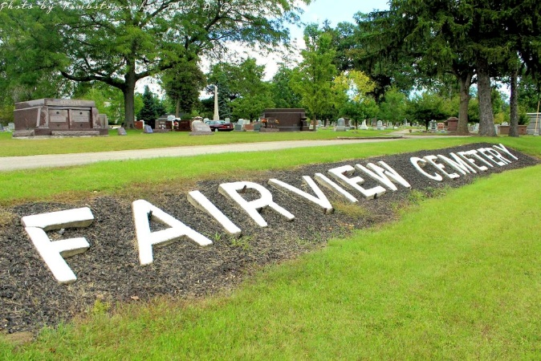
Photo by Tombstoner & Family

J. EARL BAXTER PASSED AWAY SUNDAY
Had Long Been Ill and His Death Comes From Pneumonia Complication

J. Earl Baxter, aged 26 years, a well known Keystone young man, formerly a resident of Bluffton, died at 8 o'clock Sunday morning at the home of his mother at Keystone, from pneumonia.
He had been seriously sick for a period of six or seven months, from a peculiar malady, given in a common expression as "creeping paralysis." His illness during the period preceding the pneumonia complication had been baffling to physicians, and he had been at the Robert Long hospital at Indianapolis in a vain effort to secure relief.
The deceased was a son of Benjamin Baxter and Mary (Thomas) Baxter, and was born in Decatur, Ind., on September 30, 1897, and at his death was aged 26 years, 9 months and 9 days. He had spent his entire life in Wells and Adams counties.
The family formerly lived in Bluffton, and the father of the deceased passed away in this city, seven years ago.
Surviving are the mother and five brothers and sisters, Ben Baxter and Delbert Baxter, of Wooster, Ohio; Mrs. Pearl Schlegel, of Fort Wayne; Mrs. Opal Brickley, of Huntington; and Mrs. Nellie Harden, of Bluffton.
The deceased was a member of the Bluffton Knights of Pythias lodge.
Funeral services will be held at the home at ten o'clock Tuesday forenoon, with the Rev. H. R. Spear in charge. Burial will be in Fairview cemetery.
The deceased was a member of the First Reformed church.

Bluffton Evening News, Wells County, Indiana
Monday, June 30, 1924

