Jane Lynette (Heckert) Baumgartner
September 28, 1946 – September 15, 1995

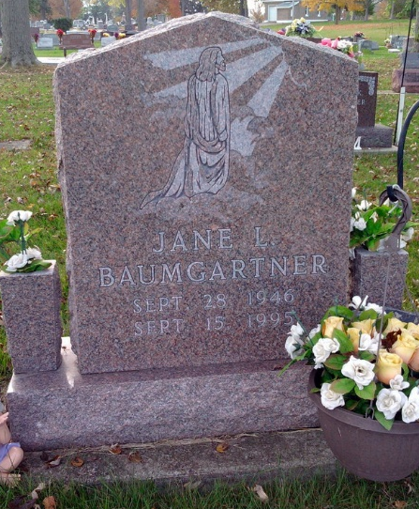
Photo by Thomas Liby

Jane L Baumgartner
in the Indiana, U.S., Death Certificates, 1899-2017
Name Jane L Baumgartner
[Jane L Heckert]
Gender Female
Race White
Age 48
Marital Status Married
Birth Date 28 Sep 1946
Birth Place Van Wert, Ohio
Death Date 15 Sep 1995
Death Place Fort Wayne, Allen, Indiana, USA
Death Registration Date 1995
Father: James Heckert
Mother: Lillian Lintemoot
Spouse: Emil H Baumgartner, Jr.
Informant: Emil H. Baumgartner, Jr.; husband; Bluffton, Indiana
Burial: September 18, 1995; Fairview Cemetery; Bluffton, Indiana

