Emil Herman Baumgartner Jr.
April 20, 1938 – June 30, 2016

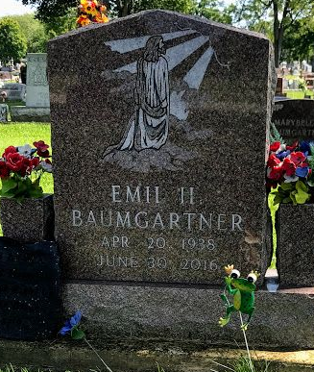
Photo by SMMR

Emil H. Baumgartner, Jr. 78 of Bluffton passed away at 10:53 a.m. on Thursday, June 30, 2016, at Bluffton Regional Medical Center.
Emil was born on April 20, 1938 in Decatur, Indiana to Emil H. Baumgartner, Sr. & Ida Jane (Lash) Aborn. He graduated from Adams Central High School and service in the United States Army from 1955 to 1963. He has lived in Wells County since 1982 and retired from working maintenance at Fleetwood in Decatur for 25 years in April of 2003.
On September 5, 1967 in Decatur, Emil and Jane Lynette (Heckert) were married and she precedes him in death on September 15, 1995.
Survivors include his children: Grace A. Scales of Bluffton, Kenneth W. Baumgartner of Bluffton, Emil H. Baumgartner III “Bub” of Arizona, Kim Hess of Decatur, Patricia Painter of Florida and 16 grandchildren and 7 step-grandchildren and 11 great-grandchildren and 4 great-step-grandchildren. He is also survived his siblings: Bill Baumgartner of Bluffton, Bob Baumgartner of Decatur, Mary Landis of Columbia City, Flossie Gable of Columbia City and Bernice Sipe of Portland.
Emil is preceded in death by his parents, his wife Jane, a son Michael J. Baumgartner and siblings: LeRoy Baumgartner, Harry Baumgartner, and Vivian Singleton.
Funeral services will be held at 11:00 a.m. Saturday (July 2, 2016) at the Thoma/Rich, Lemler Funeral Home in Bluffton. Pastor Mike Hershey will officiate. Calling Hours will take place from 4 to 8 p.m. on Friday and from 9 a.m. to 11 a.m. on Saturday, prior to the service. Burial will follow at Fairview Cemetery in Bluffton with Military Honors by both the United States Army Honor Guard and the American Legion Post #111 of Bluffton. Memorials may be made to the Friends Who Care Cancer Relief Foundation.

Thoma/Rich, Lemler Funeral Home, Wells County, Indiana
July 1, 2016

