Cora Viola (Mason) Baumgartner
November 2, 1883 – June 5, 1948

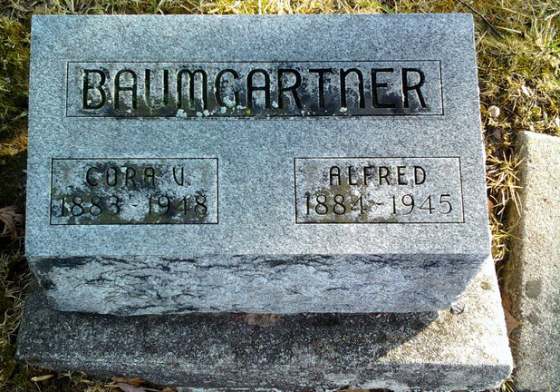
Photo by Thomas Liby

Mrs Cora Viola Baumgartner
in the Indiana, U.S., Death Certificates, 1899-2017
Name Mrs Cora Viola Baumgartner
[Mrs Cora Viola Mason]
Gender Female
Race White
Age 64
Marital Status Widowed
Birth Date 2 Nov 1883
Birth Place Wells County
Death Date 5 Jun 1948
Death Place Bluffton, Wells, Indiana, USA
Death Registration Date 1948
Father: Geo Mason
Mother: Mariah McAfee
Spouse: Alfred Baumgartner; deceased
Informant: Mrs. Albert C. Fisher; Muncie, Indiana
Burial: June 7, 1948; Fairview Cemetery; Bluffton, Indiana

