Alfred Baumgartner
October 2, 1884 – July 22, 1945

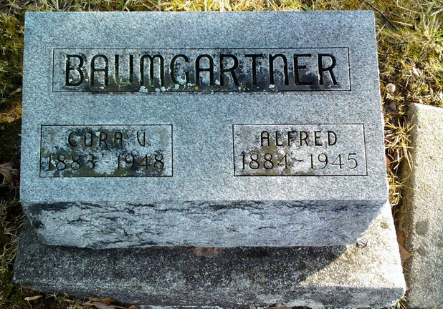
Photo by Thomas Liby

ALF BAUMGARTNER RITES THIS P.M.
NATIVE OF FRENCH TOWNSHIP DIES AT BLUFFTON SUNDAY NIGHT

Funeral services were held this afternoon at 3 o’clock at the Jahn funeral home at Bluffton, for Alfred (Alf) Baumgartner, 60, who died at his home in that city on Sunday night, following an illness of two weeks. Burial was made in Fairview cemetery.
The deceased was born in French township on October 2, 1884, a son of Peter and Mary Hawkins Baumgartner. He was married at Markle on Nov. 9, 1901, to Cora Mason, who survives. They lived in Wells county 31 years.
Surviving besides the widow are two daughters, Mrs. Grace Baller of Bluffton, and Mrs. Maro Fisher of Muncie; two sons, harry Baumgartner at home, and Harley Baumgartner of Camp Blanding, Fla.; four grandchildren’ three great-grandchildren; three sisters, Mrs. Mary Smith of near Monroe, Mrs. Hattie Studebaker and Miss Lizzie Baumgartner, both of Bluffton, and four brothers, Samuel D. Baumgartner of Fort Wayne, Lorenzo Baumgartner of Waterloo, Peter Baumgartner of Uniondale route, and J. Baumgartner of Decatur. A daughter, Hattie Marie; two sons, Harold and Jerry, and three brothers, Charles, Jacob and John are deceased.

Adams County, Indiana Historical Museum
1945a Scrapbook, image 065
Handwritten-Wed. July 25, 1945

