Wilbert S. Barton
January 27, 1871 – June 28, 1960

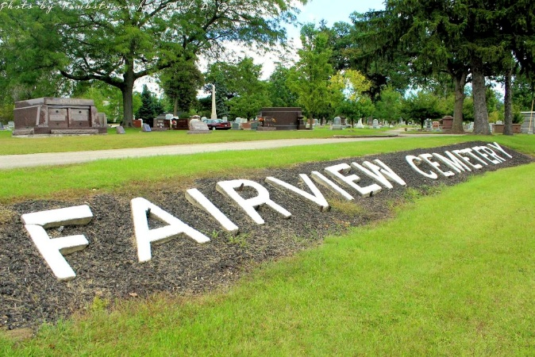
Photo by Tombstoner & Family

Wilbert Barton Dies at Age of 89
Wilbert Barton, 89, died at 1 p. m. Tuesday at the Richmond State Hospital. He had been sick six years. A retired farmer, Mr. Barton was born to Mr. and Mrs. James Barton Jan. 27, 1871. His marriage to Ida May Helwig took place Sept. 2, 1938.
Surviving are the widow; a son, Fred Barton of Flint, Mich., three stepchildren, James Dedrick of near Bluffton, Mrs. Mary Niblick of Fort Wayne, Mrs. Mabel Mosure of Morocco, Ind., two brothers, Elihue and Henry Barton, both of Muncie.
A son, Homer Barton and nine sisters are deceased.
Mr. Barton was a member of the Wesleyan Methodist Church. He has been a resident of this county his entire life. The Barton residence is at 512 East Silver St.
Friends may call after 7 o'clock this evening at the Thoma Funeral Home, where services will be conducted at 3:30 p. m. Thursday in charge of Rev. G. C. Cockrell. Burial will be at Fairview Cemetery.

Bluffton News-Banner, Wells County, Indiana
Wednesday, June 29, 1960, p. 1, c. 6

