Violet V. (Terhune) Barnell
September 6, 1917 – November 17, 2012

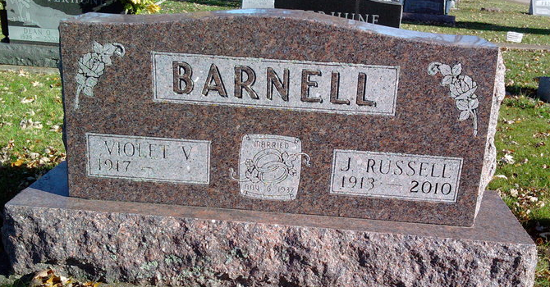
Photo by Thomas Liby

Violet V. "Vi" Barnell, 95, of Bluffton, passed away at 5:35 p.m. Saturday, November 17, 2012 at River Terrace Estates. Violet was born in Liberty Center on September 6, 1917 to Daniel and Edith (Frantz) Terhune. She married James Russell "Barney" Barnell on November 6, 1937 in Mexico, Indiana. He preceded her in death on June 8, 2010.
Violet was a life-long resident of Wells County. She had a long Clerical career working for Caylor-Nickel Clinic from 1954 to 1973 and for Wells Community Hospital from 1973 until she retired in 1987. She was a member of Epworth United Methodist Church and attended the First Church of the Nazarene.
Violet is survived by two brothers, Tom (Dorothy) Terhune of Bluffton, Jesse Terhune of Bluffton and by several nieces and nephews. In addition to her parents and husband she was preceded in death by four brothers, Elmer Terhune, Alvia Terhune, Rex Terhune, Dean Terhune and by one sister, Edna Crow.
Calling hours are 1:00 to 3:00 p.m. on Tuesday, November 20, 2012 at Thoma/Rich, Chaney & Lemler Funeral Home. Funeral services are at 3:00 p.m. on Tuesday at the funeral home with Certified Funeral Celebrant Jeff Lemler officiating. Burial will be at Fairview Cemetery. Preferred memorials are to the First Church of the Nazarene.
Thoma/Rich, Chaney & Lemler Funeral Home, Wells County, Indiana

