James Russell Barnell
December 1, 1913 - June 8, 2010

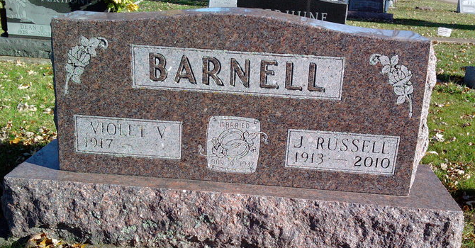
Photo by Thomas Liby

James Russell "Barney" Barnell, 96, of Bluffton, died at 2:13 a.m. Tuesday, June 8, 2010, at the Bluffton Regional Medical Center. Mr. Barnell had resided at the Meadowvale Health and Rehabilitation Center for the past two years.
Mr. Barnell was an auto body repair specialist who had worked for local car dealerships for 22 years and owned and operated his own auto body repair shop, Barnell Body Shop, for 13 years before selling it in 1974. He worked for Franklin Electric for three years and retired in 1978. He was a lifelong resident of Wells County and attended the First Church of the Nazarene.
He was born Dec. 1, 1913, in Wells County, to James W. Barnell and Mary N. Caylor Barnell. He married Violet V. Terhune Nov. 6, 1937, in Mexico, Ind.; his wife survives.
He was preceded in death by a brother, Raymond Barnell; two half-brothers, Riley Barnell and Arthur Lambert; and two half-sisters, Stella Dunckle and Greba Ogle.
Calling will be from 2 to 8 p.m. Friday at the Thoma/Rich, Chaney and Lemler Funeral Home. Services will be held at the funeral home at 10:30 a.m. Saturday with Pastor David Terhune officiating. Burial will be at the Fairview Cemetery.
Preferred memorials are to the First Church of the Nazarene.
Thoma/Rich, Chaney & Lemler Funeral Home, Wells County, Indiana

