William Maxwell Ashbaucher
October 24, 1911 – August 20, 1913

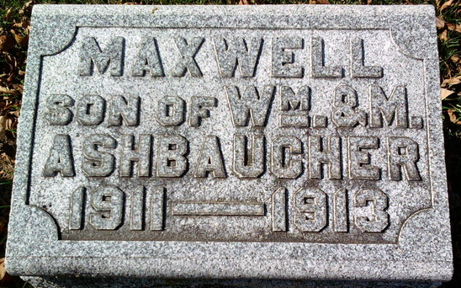
Photo by Thomas Liby

Wm Maxwell Ashbacher
in the Indiana, U.S., Death Certificates, 1899-2017
Name Wm Maxwell Ashbacher
Gender Male
Race White
Age 1
Marital Status Single
Birth Date 24 Oct 1911
Birth Place Wells Co Indiana
Death Date 20 Aug 1913
Death Place Lancaster, Wells, Indiana, USA
Death Registration Date 1913
Father: Wm Edw. Ashbacher
Mother: Kaney Mable Waugh
Informant: Family; Bluffton, Indiana
Burial: August 22, 1913; Fairview Cemetery

