William Edward Ashbaucher
September 28, 1888 – September 18, 1926

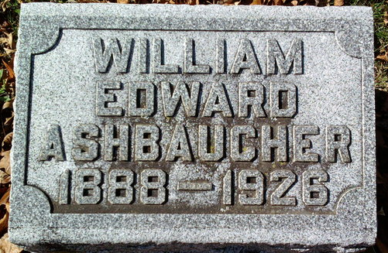
Photo by Thomas Liby

William Ashbacker
in the Indiana, U.S., Death Certificates, 1899-2017
Name William Ashbaucher
Gender Male
Race White
Age 37
Marital Status Married
Birth Date 28 Sep 1888
Birth Place Wells Co Indiana
Death Date 18 Sep 1926; suicide by drowning
Death Place Lancaster, Wells, Indiana, USA
Death Registration Date 1926 - 1927
Father: Mathew Ashbaucher
Mother: Elizabeth Beeler
Spouse: Mable Waugh
Informant: A. A. Waugh; Bluffton, Indiana
Burial: September 20, 1926; Fairview Cemetery

