Wendell Waugh Ashbaucher
May 12, 1914 – May 25, 1921

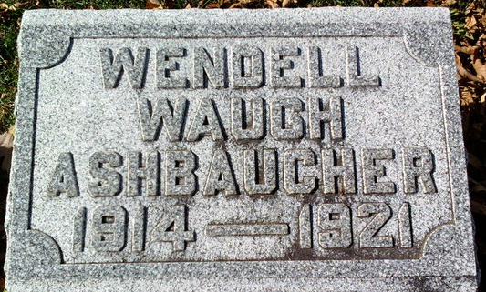
Photo by Thomas Liby

Wendell Waugh Ashbaucher
in the Indiana, U.S., Death Certificates, 1899-2017
Name Wendell Waugh Ashbaucher
Gender Male
Race White
Age 7
Marital Status Single
Birth Date 12 May 1914
Birth Place Wells Co., Indiana
Death Date 25 May 1921
Death Place Harrison, Wells, Indiana, USA
Death Registration Date 1921
Father: William Ashbaucher
Mother: Mabel Waugh
Informant: Wm. Ashbaucher; Bluffton, Indiana
Burial: May 26, 1921; Fairview Cemetery

