Elizabeth M. (Klick) Ashbaucher-Vogel
September 2, 1858 – February 4, 1930

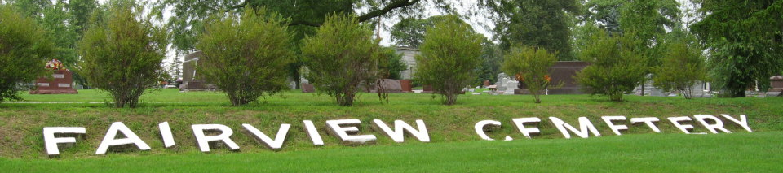
Photo by Tombstoner & Family
Mrs. Elizabeth M. Vogel
in the Indiana, U.S., Death Certificates, 1899-2017
Name Mrs. Elizabeth M. Vogel
[Mrs. Elizabeth M. Click]
Gender Female
Race White
Age 72
Marital Status Widowed
Birth Date 1 Sep 1857
Birth Place Indiana
Death Date 4 Feb 1930
Death Place Fort Wayne, Allen, Indiana, USA
Death Registration Date 1930
Father: Mr. Click
Mother: Unknown
Informant: Ralph Kump??
Burial: February 6, 1930; Fair View Cemetery
**
Marriage • Indiana Marriages, 1811-2019
Name Frederick Ashbaucher
Spouse's Name Lizzie M Klick
Officiator's Name A Gillam
Marriage Place Indiana
Event Type Marriage License
Event Date 06 Mar 1879
Event Place Wells, Indiana, United States
Page 261
Number of Images 1
**
Marriage • Indiana Marriages, 1811-2019
Name George Davidson
Residence Place *Land, , New Jersey
Birth Date 21 Sep 1848
Birthplace , , England
Race White
Number of Previous Marriages twice
Father's Name George Patterson Davidson
Mother's Name Martha Newcomb
Spouse's Name Mary Elizabeth Ashbaucher
Spouse's Residence Place Bluffton, , Indiana
Spouse's Birth Date 02 Sep 1858
Spouse's Birthplace , , Pennsylvania
Spouse's Race White
Spouse's Previous Marriage Number once
Spouse's Father's Name Emanuel D Klick
Spouse's Mother's Name Elizabeth Weinich
Event Type Marriage License
Event Date 17 Oct 1910
Event Place Wells, Indiana, United States
Page 212
Number of Images 1
**
Marriage • Indiana Marriages, 1811-2019
Name George Vogel
Residence Place , Hamilton, Ohio
Birth Date 07 Dec 1861
Birthplace , Hamilton, Ohio
Race White
Number of Previous Marriages 2
Father's Name John Vogel
Mother's Name Hanna Link
Spouse's Name Mary E Landon
Spouse's Birth Date 02 Sep 1858
Spouse's Birth Year (Estimated) 68
Spouse's Birthplace Lebanon, , Pennsylvania
Spouse's Race White
Spouse's Previous Marriage Number 4
Spouse's Father's Name Emanuel D Klick
Spouse's Mother's Name Elizabeth Weirick
Officiator's Name C G Yeoman
Marriage Place Allen
Event Type Marriage License
Event Date 23 Jun 1926
Event Place Allen, Indiana, United States
Page 412
Number of Images 1

