Nora (Quick) Ashbaucher
June 29, 1865 – April 17, 1965

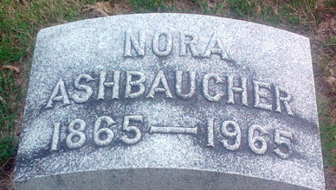
Photo by Thomas Liby

Nona Ashbacher
in the Indiana, U.S., Death Certificates, 1899-2017
Name Nona Ashbaucher
[Nona Quick]
Gender Female
Race White
Age 99
Marital Status Widowed
Birth Date 29 Jun 1865
Birth Place Indiana
Death Date 17 Apr 1965
Death Place Bluffton, Wells, Indiana, USA
Death Registration Date 1965
Father: Charley H Quick
Mother: Alice Morgan
Informant: Louise Louden; daughter; Bluffton, Indiana
Burial: April 19, 1965; Fairview Cemetery; Bluffton, Indiana

