Meta (Saurer) Ashbaucher
July 13, 1868 – December 3, 1892

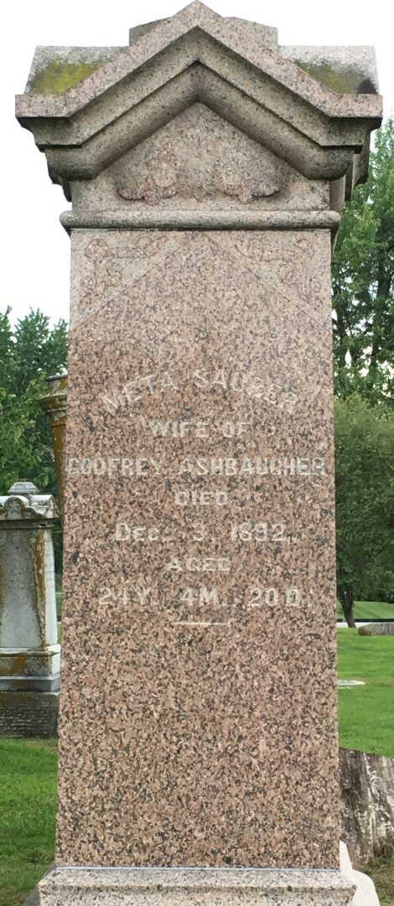
Photo by Barbara Baker Anderson

Meta Saurer from Cole Family Tree
Spouse Gautiel (aka Godfrey Aeschbacher ) Ashbaucher
Father Theophil (Gottlieb) Saurer/Sauer
Mother Elizabeth Moser
Children Boy
Birth 13 Jul 1868 Wells, Indiana, USA
Death 3 Dec 1892 Wells, Indiana, USA

