Malissa (Bollinger) Ashbaucher
February 22, 1845 – April 24, 1919

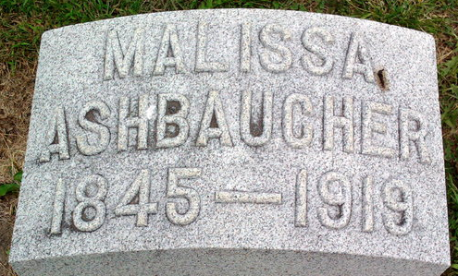
Photo by Thomas Liby

Malisa Ashbaugher
in the Indiana, U.S., Death Certificates, 1899-2017
Name Malissa Ashbaugher
[Malissa Bollinger]
Gender Female
Race White
Age 74
Marital Status Widowed
Birth Date 22 Feb 1845
Birth Place Ohio
Death Date 24 Apr 1919
Death Place Bluffton, Wells, Indiana, USA
Death Registration Date 1919
Father: Phillip Bollinger
Mother: Elizabeth Stoneburner
Spouse: John Ashbaugher; deceased
Informant: Frank Ashbaugher; Bluffton, Indiana
Burial: April 26, 1919; Fairview Cemetery

