Louisa (Saurer) Ashbaucher
February 27, 1864 – March 14, 1900

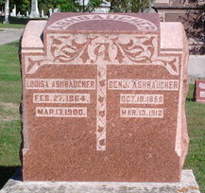
Photo by Thomas Liby

Louisa Aschbacher
in the Indiana, U.S., Death Certificates, 1899-2017
Name Louisa Aschbacher
[Louisa Auren]
Gender Female
Race White
Age 36 years, 0 months, 0 days
Marital Status Married
Birth Date abt 1864
Birth Place Near Bluffton Indiana
Death Date 14 Mar 1900
Death Place Bluffton, Wells, Indiana, USA
Death Registration Date 1899 - 1900
Father: Gotlieb Sowers?
Mother: Moser
Informant: Harry Deam; Bluffton, Indiana
Burial: March 16, 1900; Bluffton, Indiana

