Lillie B. (Falk) Ashbaucher
May 21, 1874 – September 26, 1942

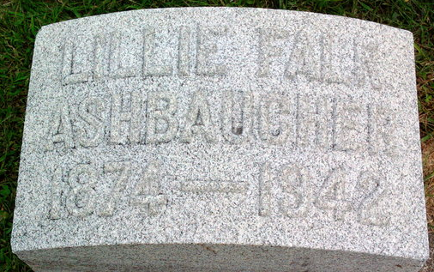
Photo by Thomas Liby

Lillie B Ashbaucher
in the Indiana, U.S., Death Certificates, 1899-2017
Name Lillie B Ashbaucher
[Lillie B Falk]
Gender Female
Race White
Age 68
Marital Status Widowed
Birth Date 21 May 1874
Birth Place Bluffton, Indiana
Death Date 26 Sep 1942
Death Place Bluffton, Wells, Indiana, USA
Death Registration Date 1942
Father: John A Falk
Mother: Philona Goff
Spouse: B Franklin Ashbaucher
Informant: Lorin Ashbaucher; Bloomington, Indiana
Burial: September 29, 1942; Fairview Cemetery; Bluffton, Indiana

