John Ashbaucher
1847 – June 27, 1911

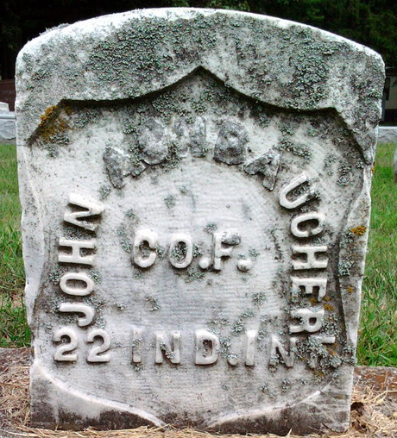
Photo by Thomas Liby
The funeral of John Ashbaucher of Bluffton, well known here, whose death occurred at Bluffton Tuesday noon, will be held Thursday morning at 10 o'clock at the Reformed Church. The deceased was sixty-four years old.

Decatur Daily Democrat; Adams County, Indiana
Wednesday, June 28, 1911
**
U.S., Civil War Soldier Records and Profiles, 1861-1865
Name John Ashbaucher
Enlistment Date 14 Oct 1864
Enlistment Rank Private
Muster Date 14 Oct 1864
Muster Place Indiana
Muster Company F
Muster Regiment 74th Infantry
Muster Regiment Type Infantry
Muster Information Enlisted
Muster Out Date 9 Jun 1865
Muster Out Place Washington, District of Columbia
Muster Out Information Transferred
Side of War Union
Survived War? Yes
Residence Place Vera Cruz, Indiana
Additional Notes 2 Muster 2 Date: 09 Jun 1865; Muster 2 Place: Indiana; Muster 2 Unit: 572; Muster 2 Company: F; Muster 2 Regiment: 22nd Infantry; Muster 2 Regiment Type: Infantry; Muster 2 Information: Transferred; MusterOut 2 Date: 25 Jul 1865; MusterOut 2 Place: Washington, District of Columbia; MusterOut 2 Information: Mustered Out;
Title Report of the Adjutant General of the State of Indiana; National Archives: Index to Federal Pension Records
**
Web: Indiana, U.S., Civil War Soldier Database Index, 1861-1865
Name John Ashbaucher
Birth Year abt 1846
Age 18
Enrollment Date 7 Oct 1864
Place Kendallville, Indiana
Company F
Regiment 74
Notes Recruit. Transferred to 22 Regiment. Substitute. Farmer.
**
U.S., Civil War Pension Index: General Index to Pension Files, 1861-1934
Name John Ashbaucher
Gender Male
Unit F 22; F 74 Ind, Infantry
Filing Date 14 Jul 1890 as invalid
Filing Place Indiana, USA
Relation to Head Soldier
Spouse: Malisa Ashbaucher; filed July 3, 1911 as widow

**
Johan (John) Ashbaucher from Hixon Family Tree
Spouse Mellissa Bolinger
Father John [Johan] Ashbaucher [Aeschbacher]
Mother Anna Schene (Scheidegger)
Children Oliver MacAndie
Birth 1849 Bern, Switzerland
Death 27 Jun 1911
Residence 1880 Adams, Indiana, USA

