Hattie (King) Ashbaucher
July 2, 1846 – February 18, 1888

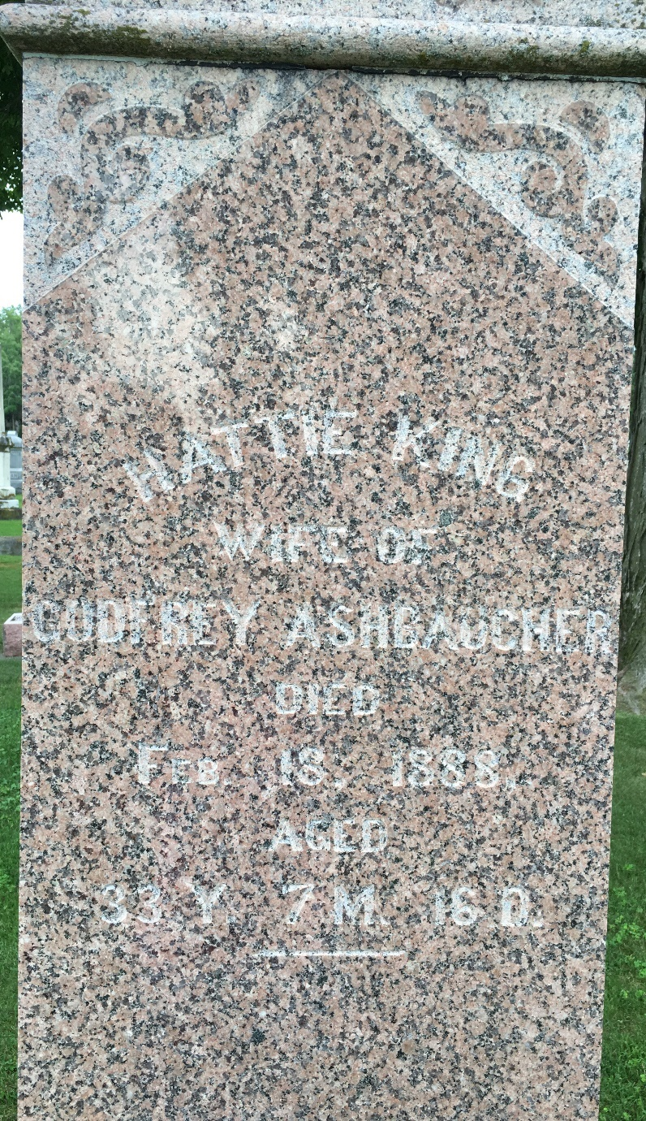
Photo by Barbara Baker Anderson

No further information found at this time

