Grace E. (Deam) Ashbaucher
September 11, 1889 – August 16, 1986

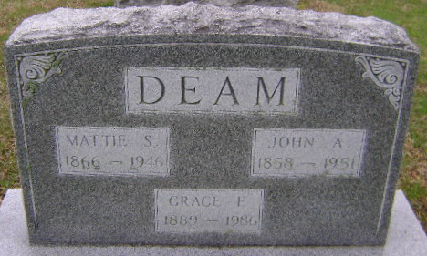
Photo by Bruce Sonner

Grace E Ashbaucher
in the Indiana, U.S., Death Certificates, 1899-2011
Name: Grace E Ashbaucher
[Grace E Deam]
Gender: Female
Race: White
Age: 96
Marital status: Widowed
Birth Date: 11 Sep 1889
Birth Place: IN
Death Date: 16 Aug 1986
Death Place: Bluffton, Wells, Indiana, USA
Father: John A Deam
Mother: Mattie S Ware
Informant: Daisy Cox; niece; Bluffton, Indiana
Burial: August 19, 1986; Fairview Cemetery; Bluffton, Indiana

