Godfrey Ashbaucher
February 7, 1854 – July 1, 1918

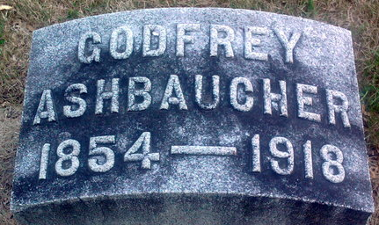
Photo by Thomas Liby

Godfrey Ashbaugh
in the Indiana, U.S., Death Certificates, 1899-2017
Name Godfrey Ashbaucher
Gender Male
Race White
Age 64
Marital Status Married
Birth Date 7 Feb 1854
Birth Place Switzerland
Death Date 1 Jul 1918
Death Place Harrison, Wells, Indiana, USA
Death Registration Date 1918
Father: John Ashbaucher
Mother: Anna Schamey
Spouse: Nona Quick
Informant: Frank Ashbaugher; Bluffton, Indiana
Burial: July 3, 1918; Fairview Cemetery

