George E. Ashbaucher
1883 – December 5, 1905

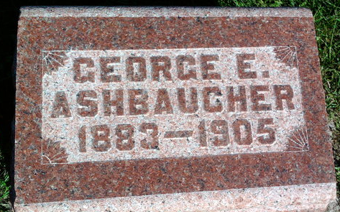
Photo by Thomas Liby
GEORGE ASHBAUCHER DIED AT PHOENIX
George Ashbaucher, a former Bluffton boy, who was reported seriously sick at Phoenix, Arizona, died Tuesday night. A telegram to this effect was received in Bluffton yesterday by the parents of the deceased. The remains will be sent to Bluffton for interment and are expected to arrive by Sunday.
He was twenty-three years old and a son of Mr. and Mrs. Ben Ashbaucher.
Daily Democrat, Adams County, Indiana
A weekly newspaper
Thursday, December 7, 1905
**
LINN GROVE
F. D. Hoffman, and wife of this place, and M. F. French and wife, and Eli Bierie and wife of East Nottingham Township, attended the George Ashbaucher funeral at Bluffton on Tuesday.
Daily Democrat, Adams County, Indiana
A weekly newspaper
Thursday, December 14, 1905
**
Death • Arizona Deaths, 1870-1951
Name Geo. Ashbaucher
Address Sister's Hospital
Sex Male
Age 23y
Marital Status Single
Ethnicity German
Race White
Birth Year (Estimated) 1882
Death Date 05 Dec 1905
Death Place Phoenix, Maricopa, Arizona
Burial Place Buffergton, Ind.
Record Number 393
**
George E Ashbaucher from Prochnow-Mathwick-Mertz-Krehl Family Tree
Father Benjamin Ashbaucher
Mother Harriet King
Birth Feb 1883 Indiana, USA
Death 5 Dec 1905 Maricopa, Pinal, Arizona, USA
Residence 1900 Wells, Indiana, USA

